**MODULE 1**

**Packaging Evolution: From Basics to 3D Integration**

1. Introduction To Semiconductor Packaging and Industry Overview

WHY PACKAGING?

* To enable the die to work in a real world

Requirements :

* Protection of semiconductor devices on the die
* Connection of die to other dies

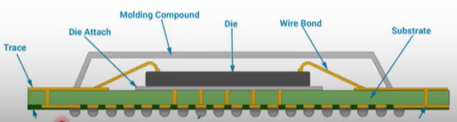

PACKAGING AND TESTING INDUSTRY

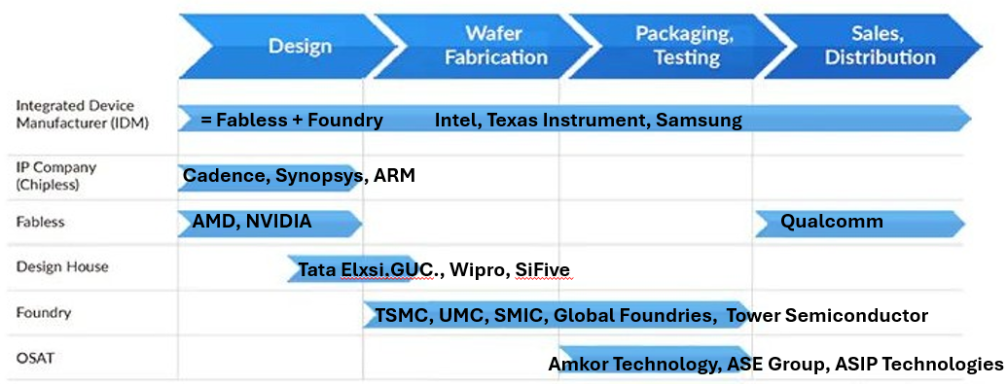

1. Understanding Package Requirements And Foundational Package Types

Package Requirements :

* Application-specific Requirements
* Electrical Requirements
* Thermal Requirements
* Mechanical and Physical constraints
* Cost Considerations
* Reliability and Durability

Packaging Structure :

What consists in a Package?

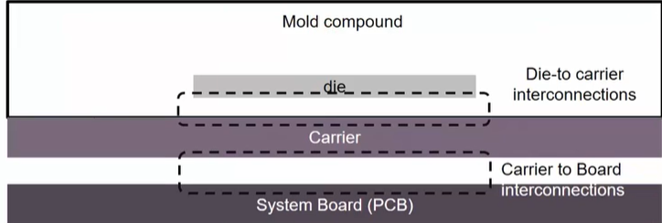

Type of Packaging Technologies :

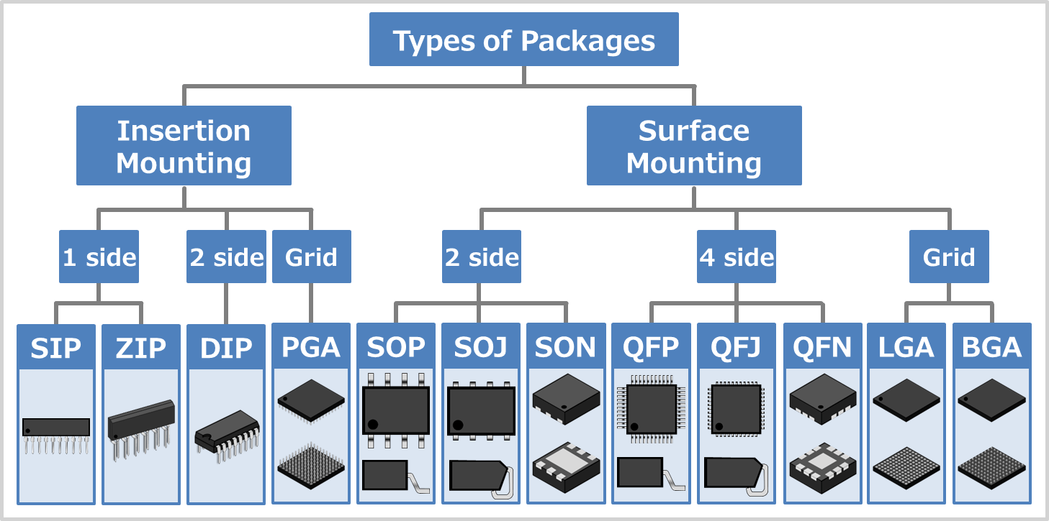

* Through-hole Mounting
  + TO : Transistor Outline
  + SIP : Single In-line Package
  + DIP : Dual In-line Package
  + PGA : Pin Grid Array
* Surface Mount Technology:
  + (T)SOT : (Thin) Small Outline Transistor
  + (T)SOP : (Thin) Small Outline Package
  + SOIC : Small Outline IC Package
  + QFN : Quad Flat No-leads
  + QFP : Quad Flat Package
  + PBGA : Plastic Ball Grid Array
  + LGA : Land Grid Array
  + FCBGA : Flip Chip Ball Grid Array
  + CSP : Chip Scale Package
* Advanced Packages
  + PoP : Package on Package (Qualcomm SD series, Apple A-Series, Samsung Exynos etc.)
  + MCM : Multi-Chip Module (eg: Intel Broadwell)
  + SiP : System-in-Package (Apple S1)
  + CoWoS : Chip on Wafer on Substrate (eg: Nvidia GP100, GV100, GA100, etc.)
  + CoPoS (Chip-on-Panel-on-Substrate) ( eg: Samsung (leader), ASE, Amkor (panel-level OSAT players)
  + CoWoP (Chip-on-Wafer-on-Printed Circuit Board) (eg: Intel (adapting with EMIB/Foveros + PCB concepts), ASE, Amkor, Ibiden, Shinko, AT&S)

1. Evolving Package Architectures – From Single to Multi Chip Modules

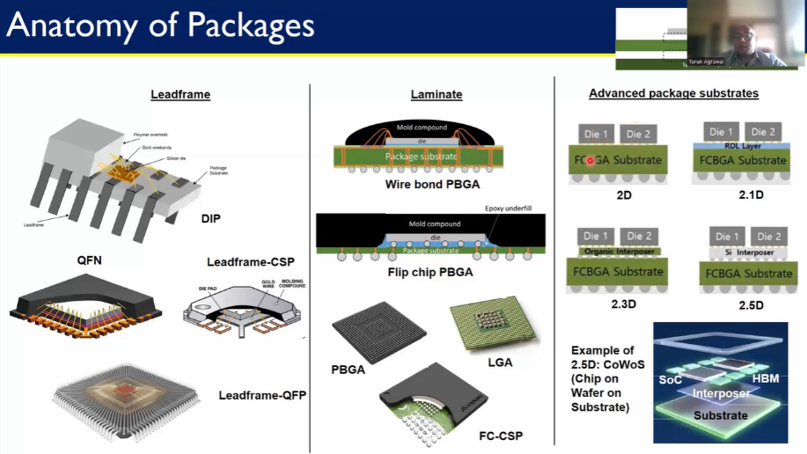

* Leadframe-Based Packages
  + DIP: Traditional, with wirebonds and external leads
  + QFN: Compact with exposed thermal pads
  + Leadframe CSP & QFP: Scaled for density and SMT
* Laminate-Based Packages
  + PBGA: Wirebonded to laminated substrates
  + Flip Chip PBGA: Superior signal and thermal performance
  + LGA, FCCSP: Common in modern devices
* Advanced Substrates
  + 2D: Dies placed side-by-side on the same substrate
  + 2.1D: Adds RDL for better routing
  + 2.3D: Uses organic interposers
  + 2.5D: Silicon interposer for high-speed interconnects (e.g.: CoWoS, CoWop, CopoS)

1. Interposers Re-distribution Layers and 2.5D/ 3D Packaging Approaches
   * Redistribution Layer (RDL) : Extra metal layer on die/wafer to reroute I/O pads, used in FO-WLP, FO-BGA, PLP, SiP, multi-die integration
   * Interposers : Intermediate layer between die & substrate for dense routing/power, There are 2 types of interposers Silicon, Organic, Glass used for Signal routing, thermal management, high bandwidth die-to-die links
   * 2.5D / 3D Integration : 2.5D is Side-by-side dies on interposer (e.g., CPU + HBM in GPUs/HPC), 3D is Vertical die stacking with TSVs (e.g., HBM stacks, 3D NAND, logic-on-logic)
2. Comparative Analysis And Selecting The Right Packaging Solution

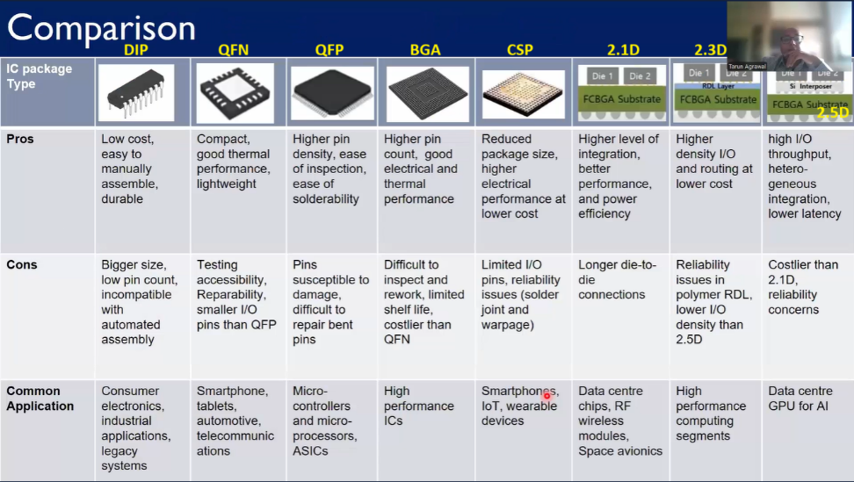

* To choose the right package we consider the following parameters.

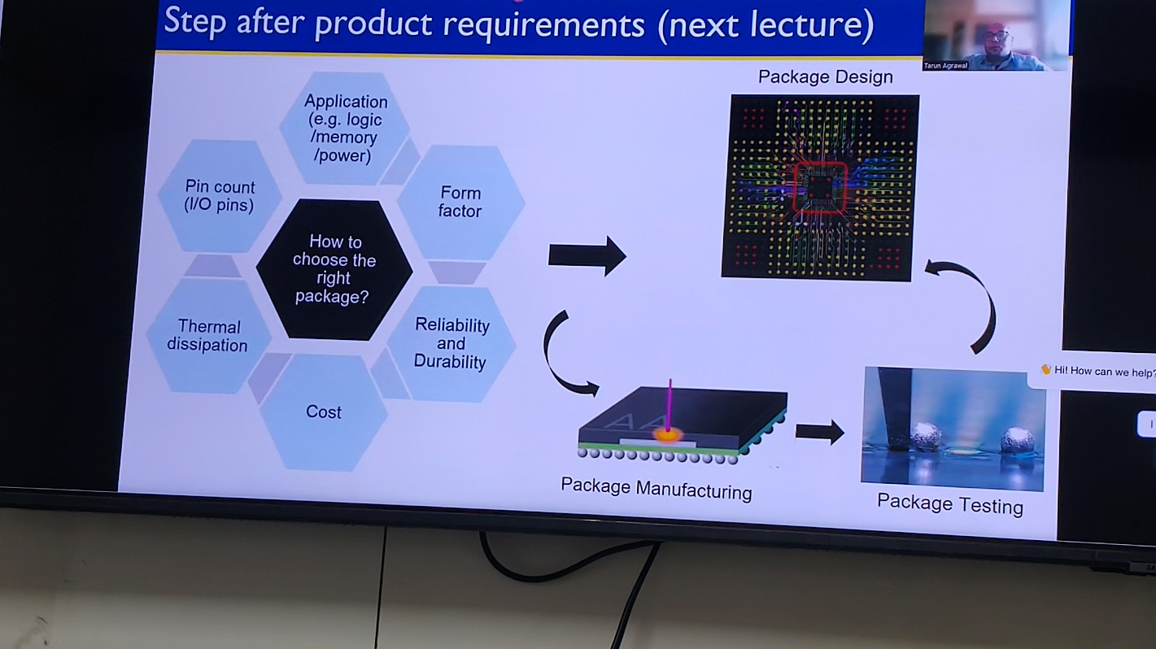

**MODULE 2**

**From Wafer to Package: Assembly and Manufacturing Essentials**

1. Setting The Stage - Supply Chain And Facilities

* Many Design houses, OEMs, and Fab companies are involved.

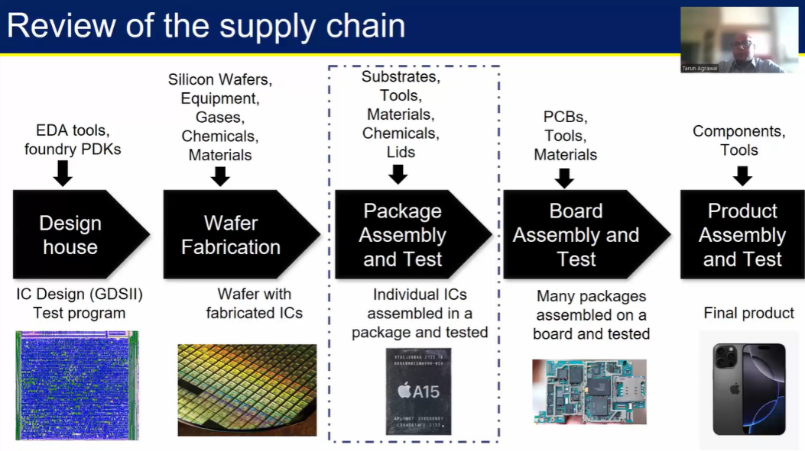

* ATMP
  + The activities include Assembly, Testing, Marking, Packaging.

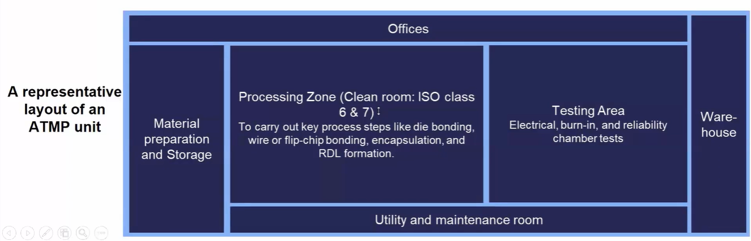

1. Wafer Pre-Preparation - Grinding And Dicing
   * Wafers first arrive in protective carriers to prevent contamination and are inspected for surface defects or damage. A protective tape is then laminated on the device side to safeguard the wafer during thinning and cutting
   * The wafer’s backside is ground down from about 700 µm to around 200 µm to improve thermal performance and flexibility, after which it is mounted on a ring frame with adhesive tape to keep it stable for dicing. Finally, a two-step dicing process is performed: laser grooving weakens the wafer along scribe lines, followed by blade dicing to separate it into individual dies

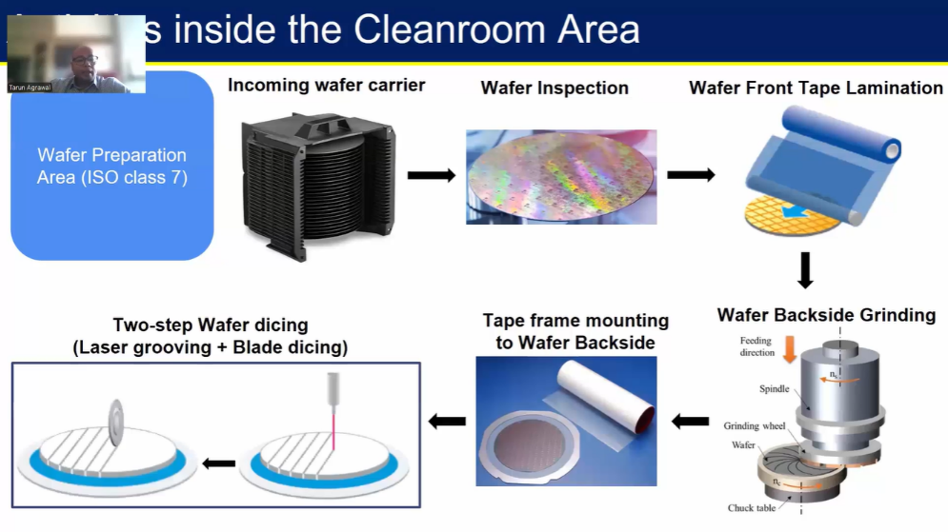

1. Wire Bond Packaging - Die Attach To Molding
   * The die is first attached to a substrate or lead frame using epoxy, dispensed in patterns to prevent voids, and then cured by heating to ensure a strong bond. Fine gold or aluminum wires are then connected between die pads and substrate pads through wire bonding, involving ball bond formation, wire looping, and crescent bonding
   * The assembly is encapsulated with transfer molding resin to protect it from stress and contamination, marked with a laser for identification, and finally singulated using a thin dicing blade to separate precise individual ICs

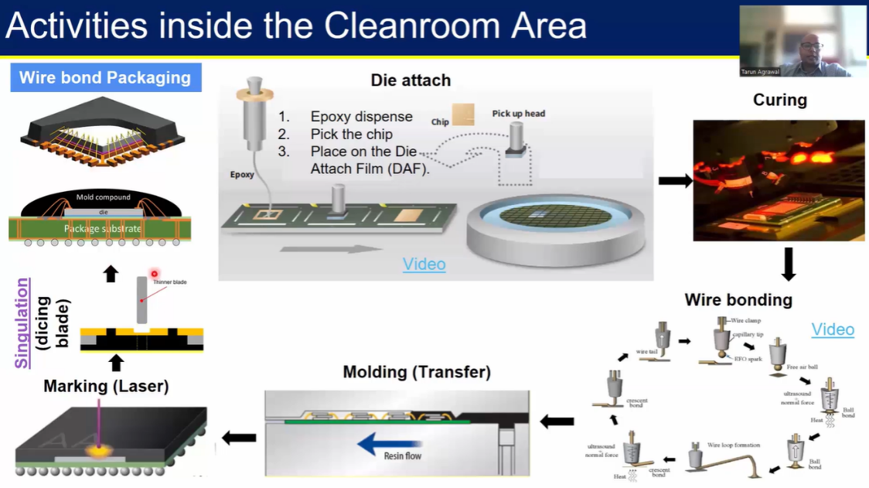

1. Flip Chip Assembly - Bump Formation And Underfill
   * Flip chip packaging improves electrical performance and I/O density by mounting the die face-down on the substrate. The process begins with solder bump formation on the die, followed by reflow to create strong electrical and mechanical connections
   * The chip is then flipped, aligned with the substrate pads, and attached through solder reflow, after which excess flux is cleaned. Underfill is dispensed and cured to enhance mechanical strength and thermal performance, and the assembly is encapsulated with a protective molding compound
   * Finally, laser marking provides identification and traceability, and solder balls are mounted and reflowed onto the substrate to complete the package

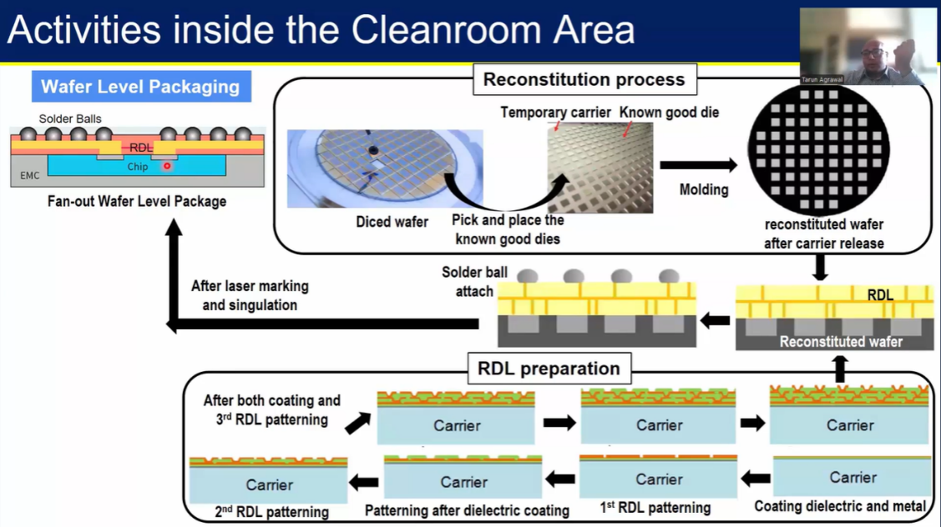

1. Wafer Level Packaging And Conclusion
   * Wafer-Level Packaging (WLP) is done before dicing, making chips smaller and cheaper. Fan-in WLP redistributes I/O pads within the die, while Fan-out WLP extends them beyond using RDLs for higher density
   * In FO-WLP, good dies are placed on a carrier, molded into a reconstituted wafer, and RDL layers are built. Solder balls are then attached, and the wafer is laser-marked and singulated into individual packages

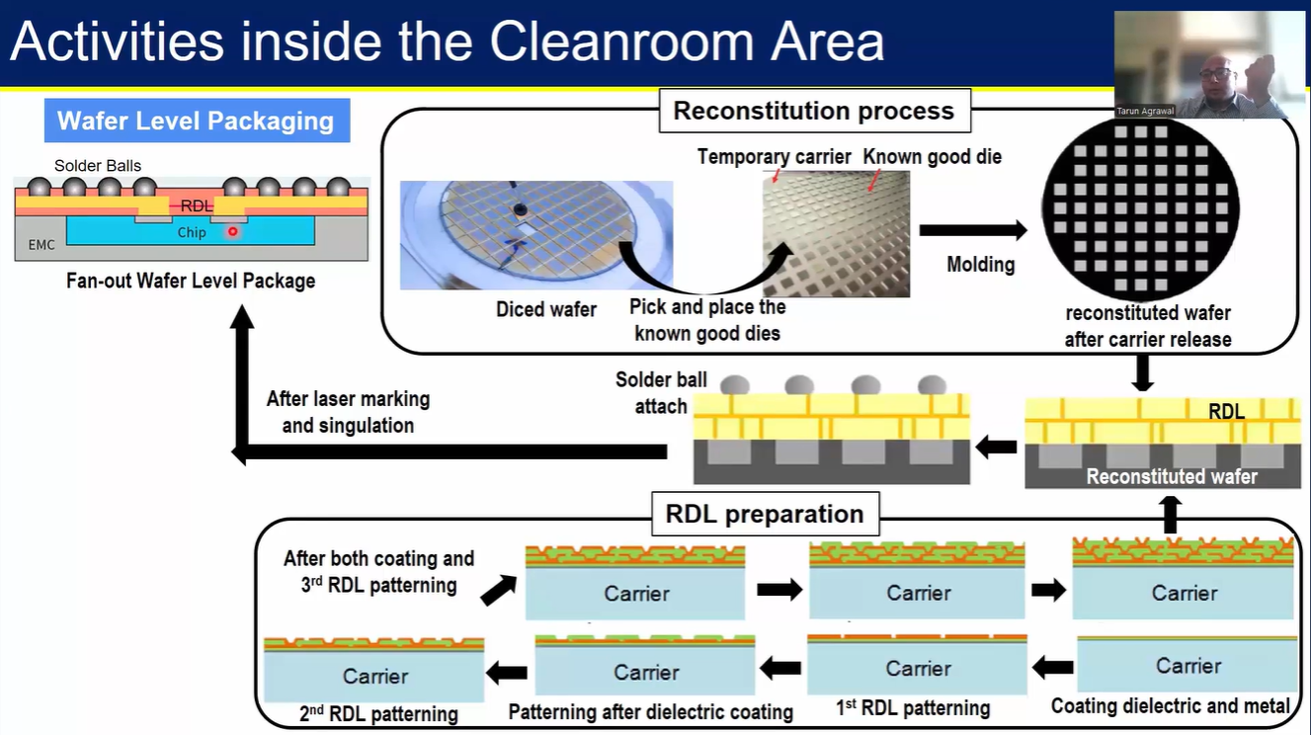

**MODULE 3**

**Labs: Thermal Simulation of Semiconductor Packages with ANSYS**

1. Introduction And Getting Started With ANSYS Electronics Desktop
   * Installed ANSYS , using Icepack

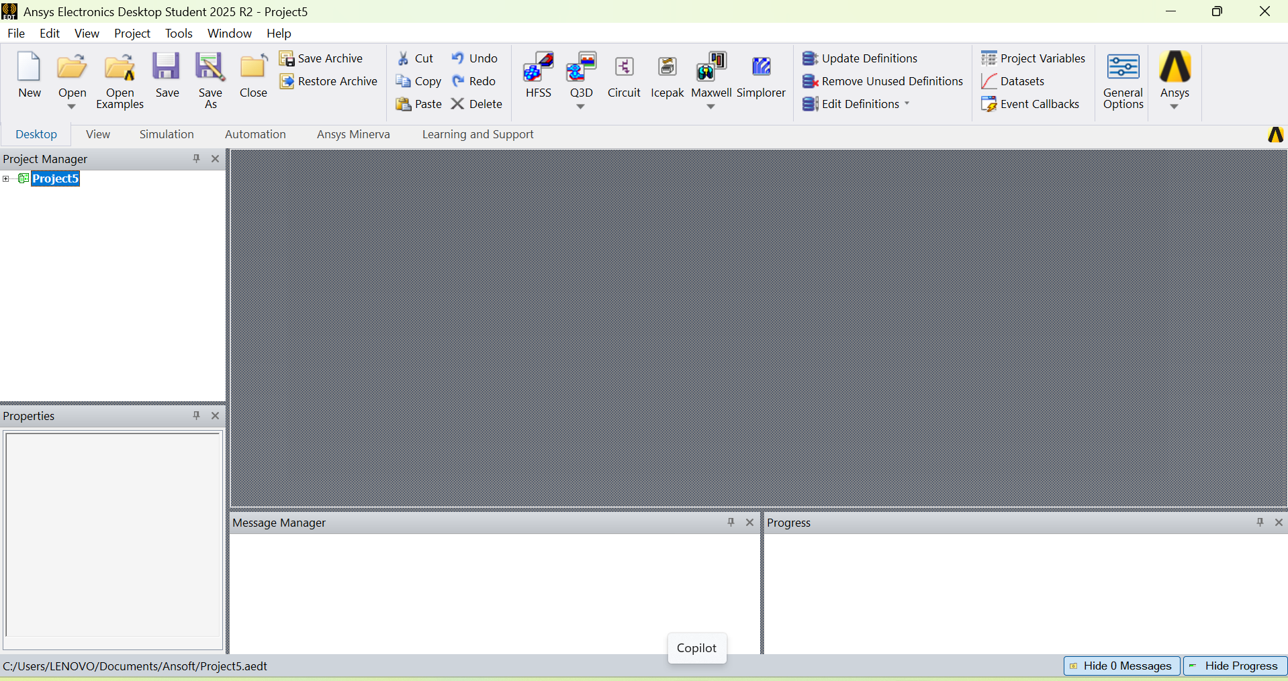

1. Setting Up A Flip-Chip BGA Package
2. Material Definitions And Thermal Power Sources
3. Meshing And Running The Thermal Analysis
4. Viewing Results And Exploring Other Package Types
   * Following the below flow to create the package, defining the materials, dimensions and meshing, running thermal analysis and viewing results for all the above mentioned analysis
   * Similarly we can try other packages as well

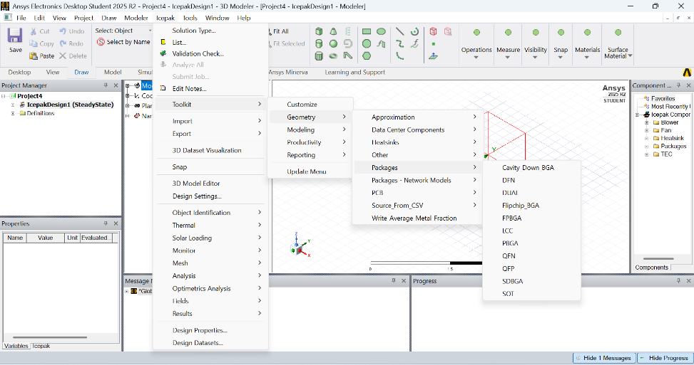

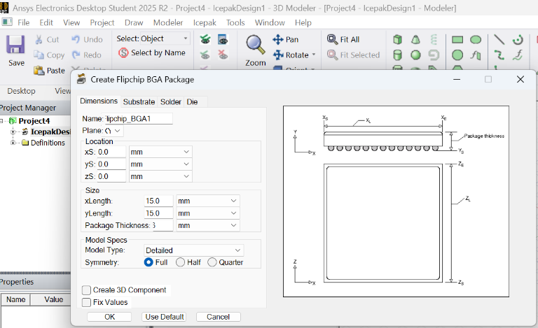

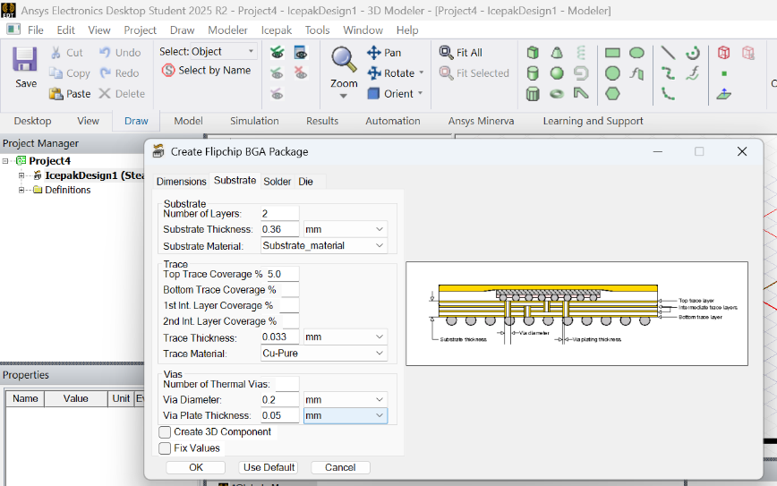

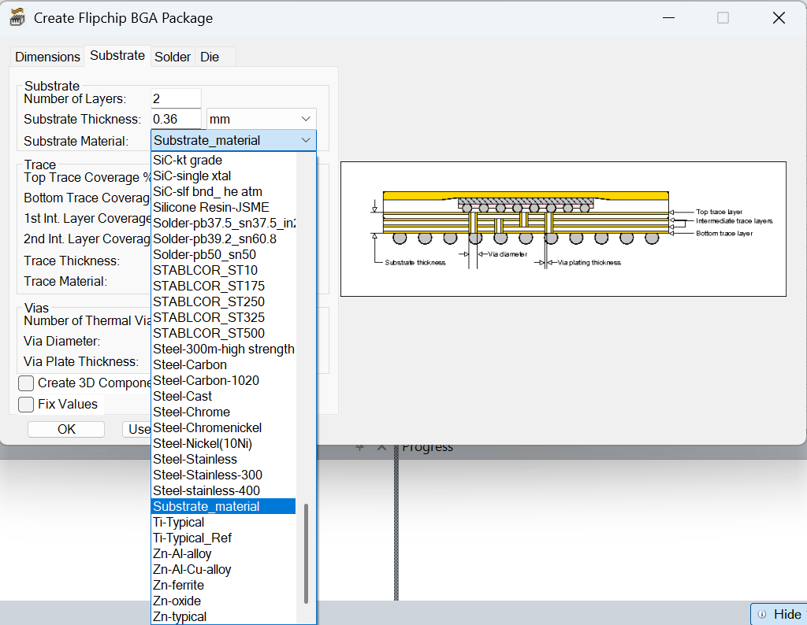

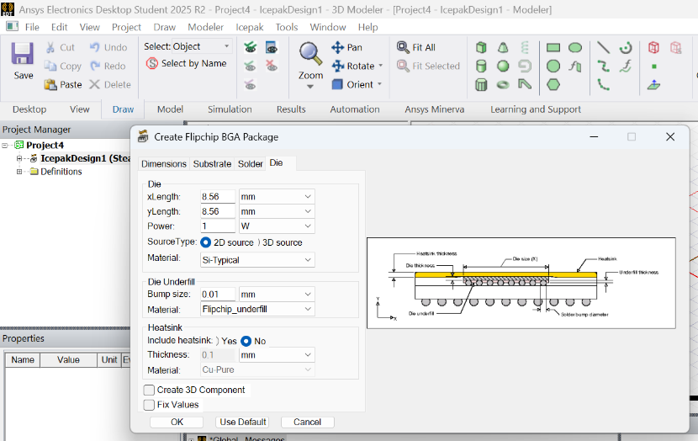

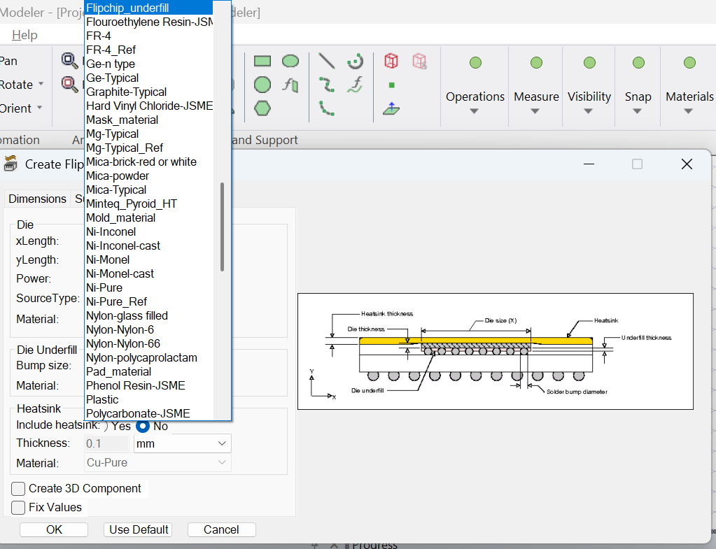

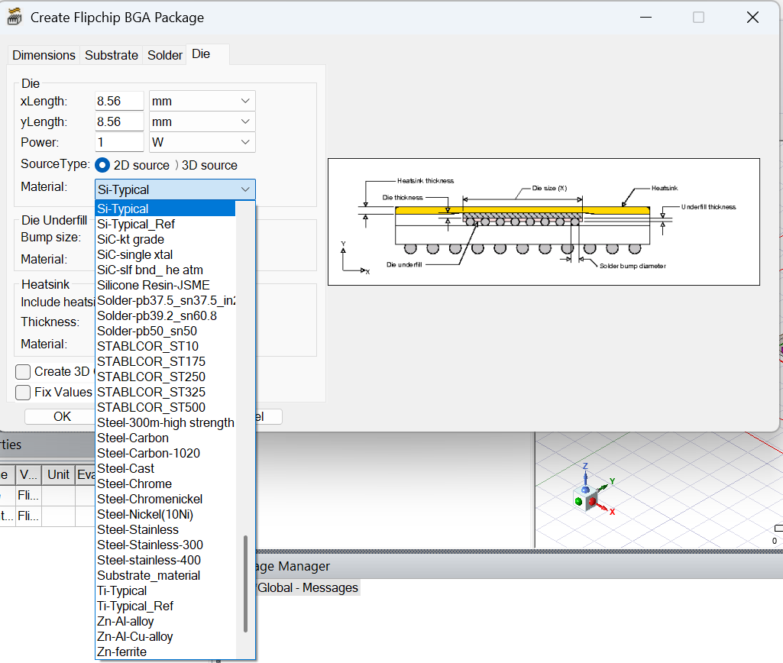

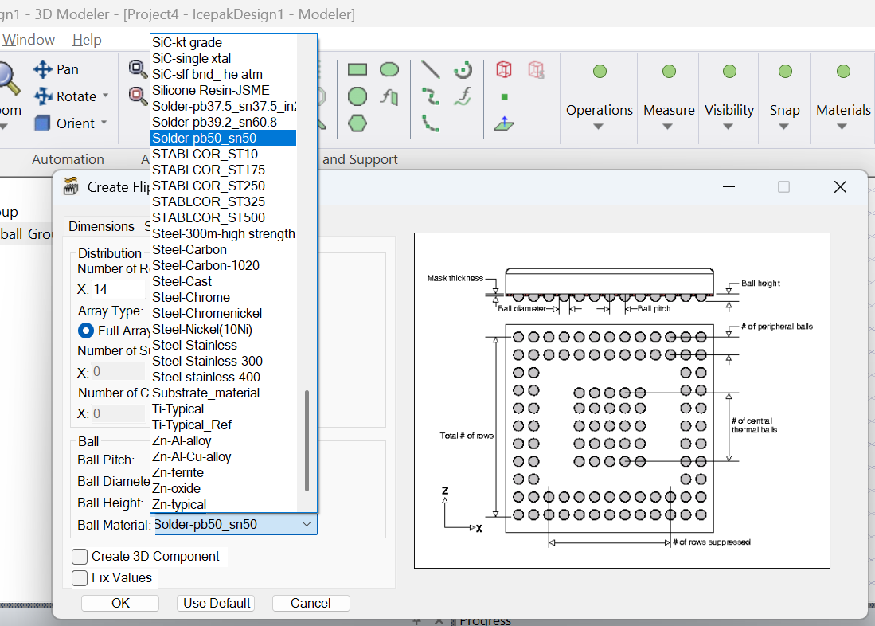

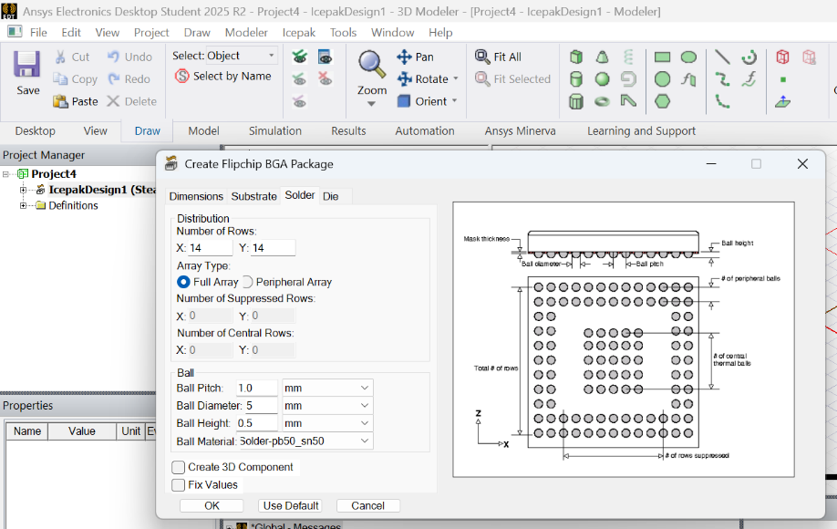

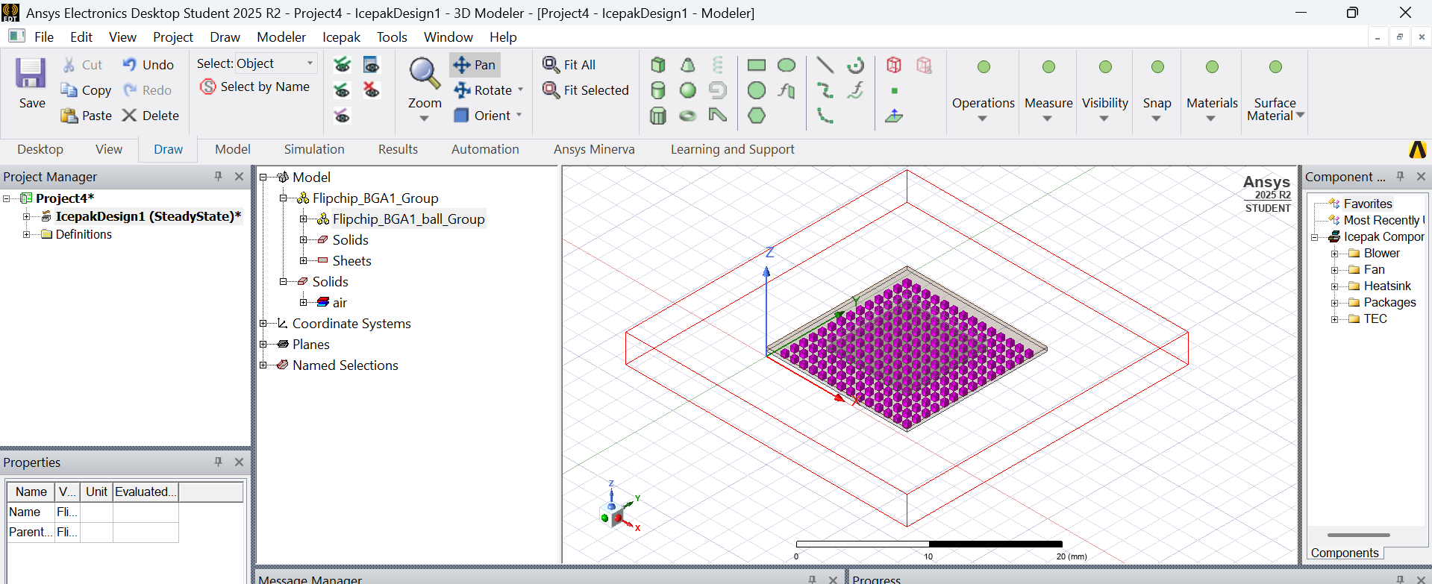

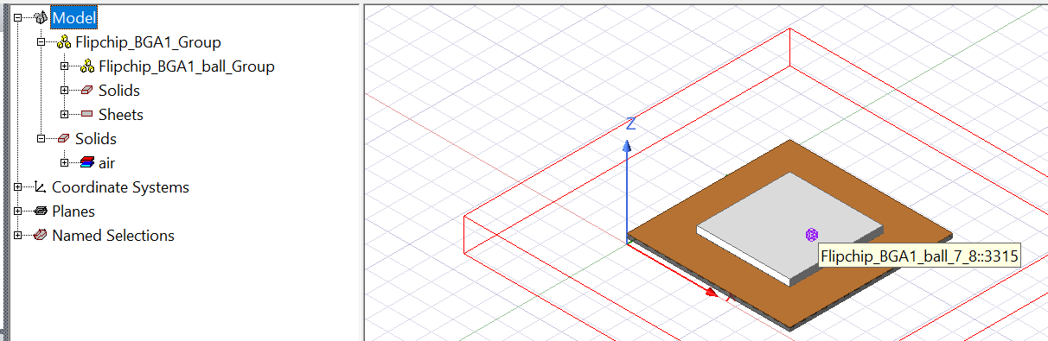

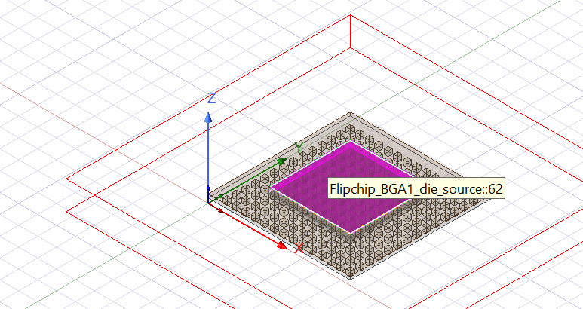

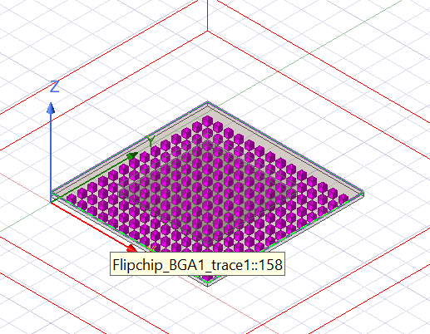

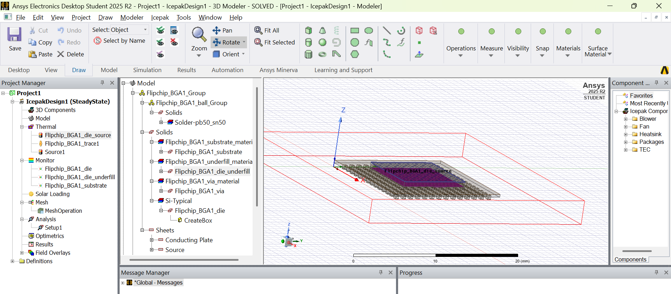

Different Plot Fields

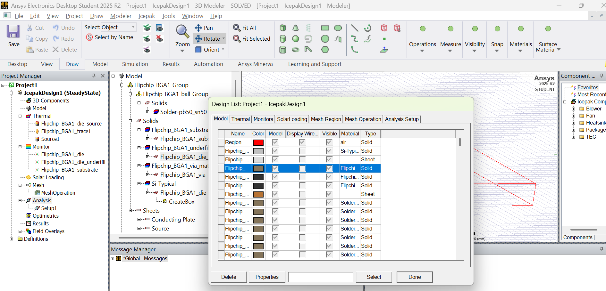

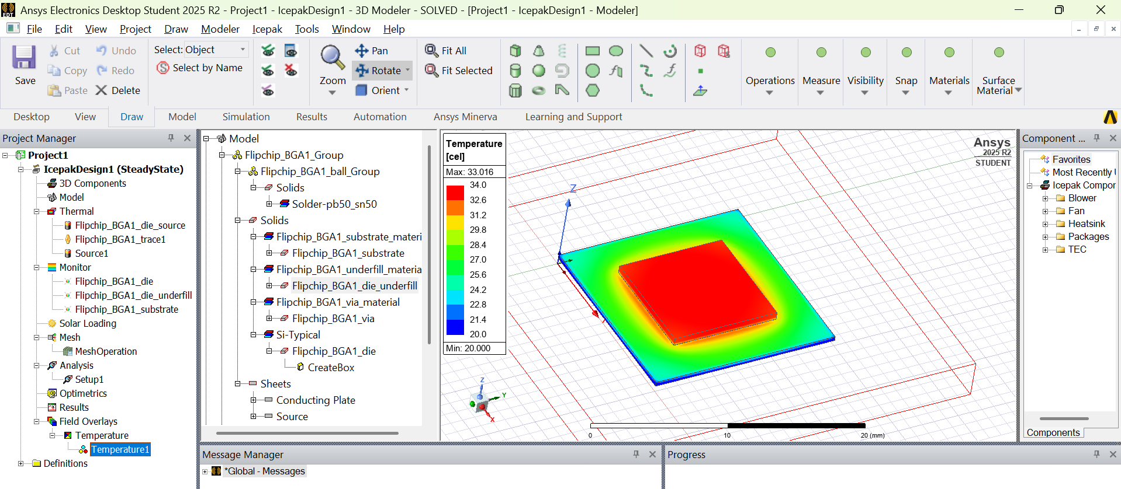

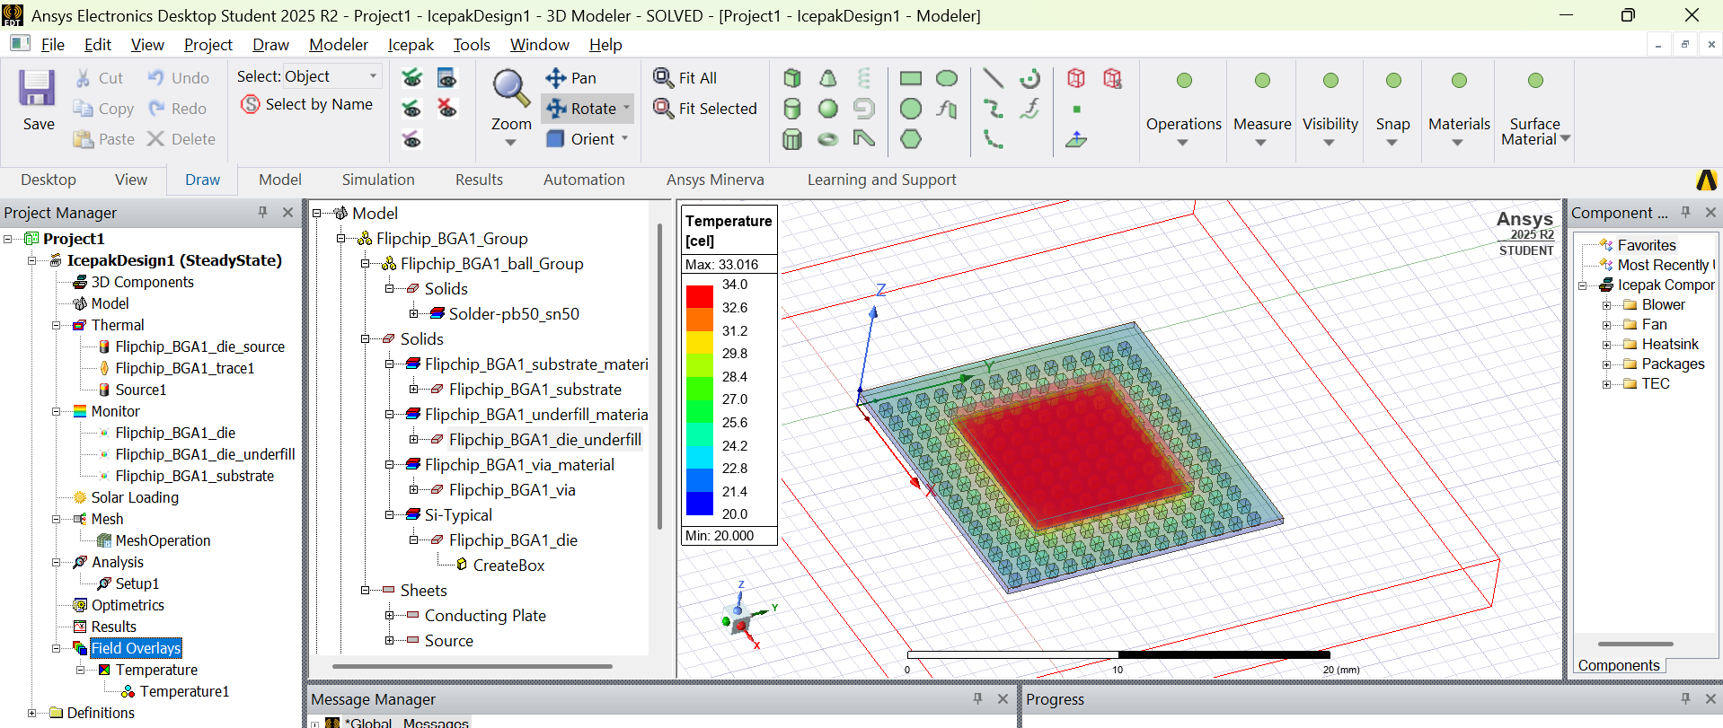

MESH Operation Results

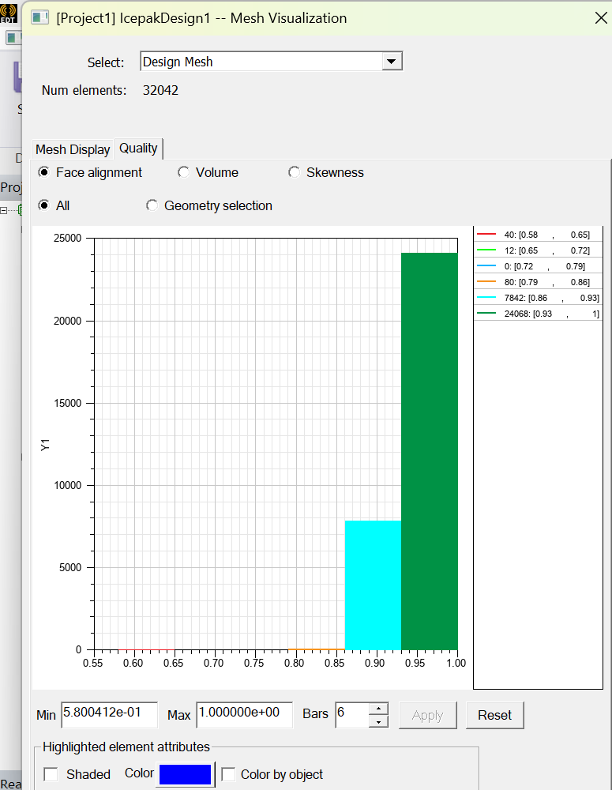 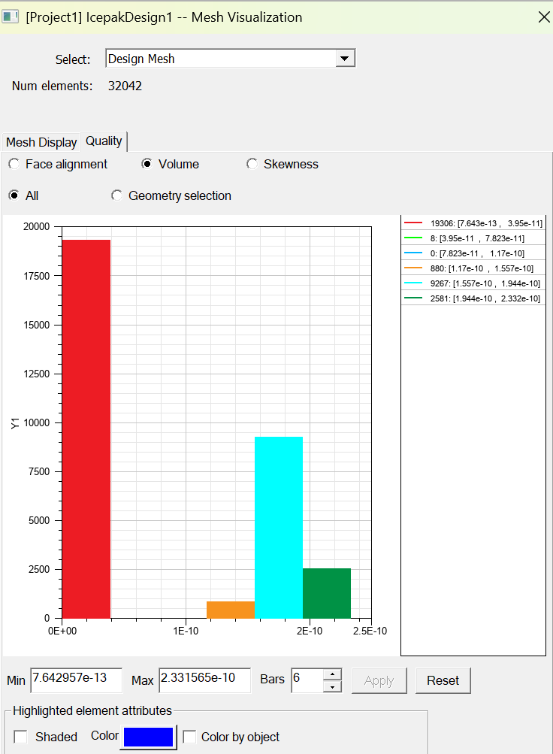

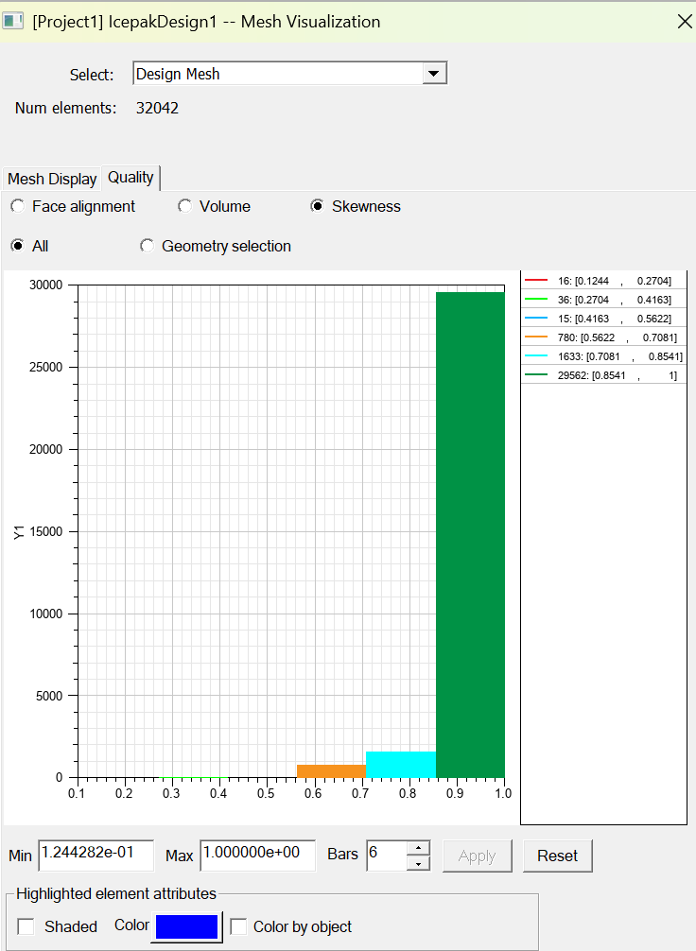

Validating the model

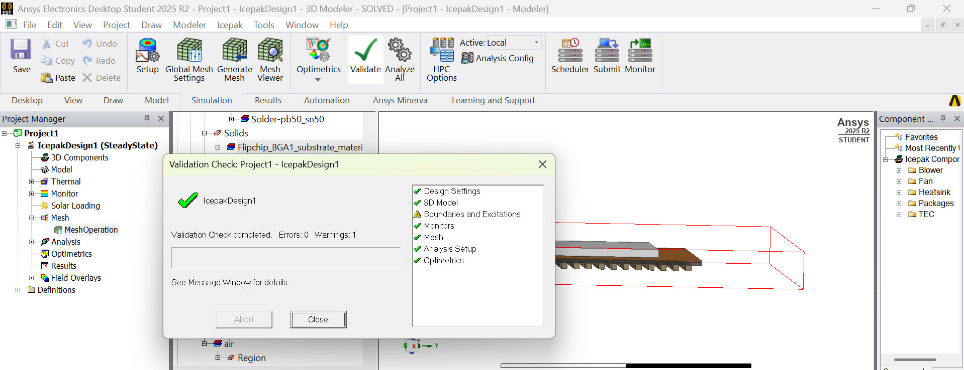

**MODULE 4**

**Ensuring Package Reliability: Testing and Performance Validation**

1. Introduction to Package Testing and Electrical Functionality Checks

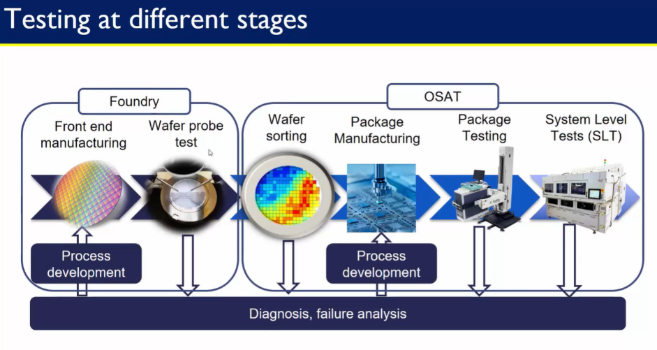

Testing and Functionality Checks are done at each stage of manufacturing as well.

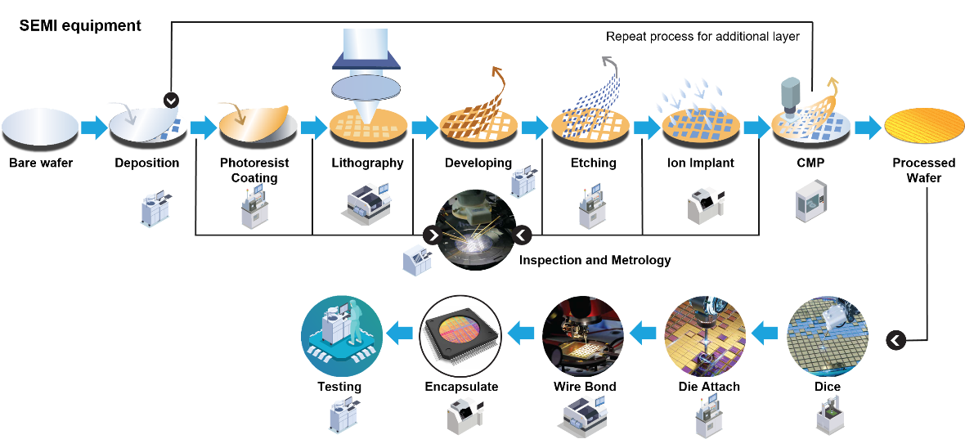

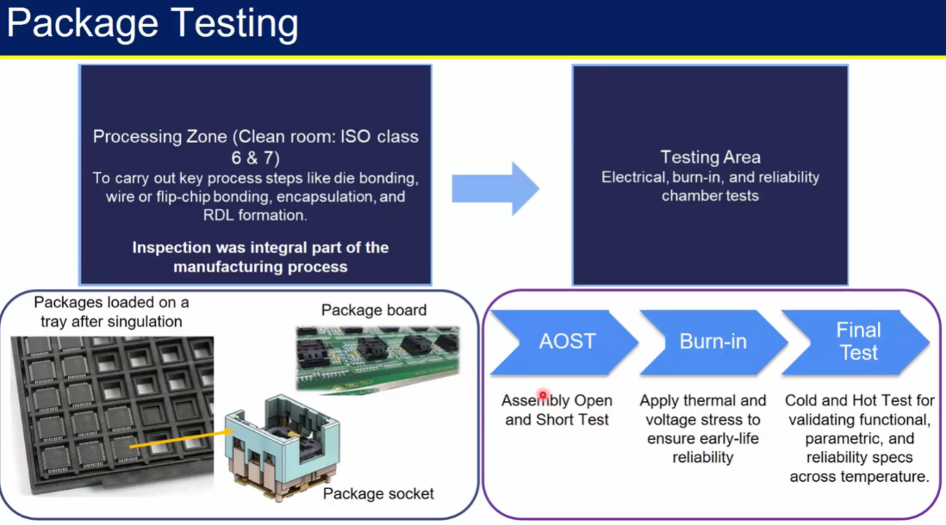

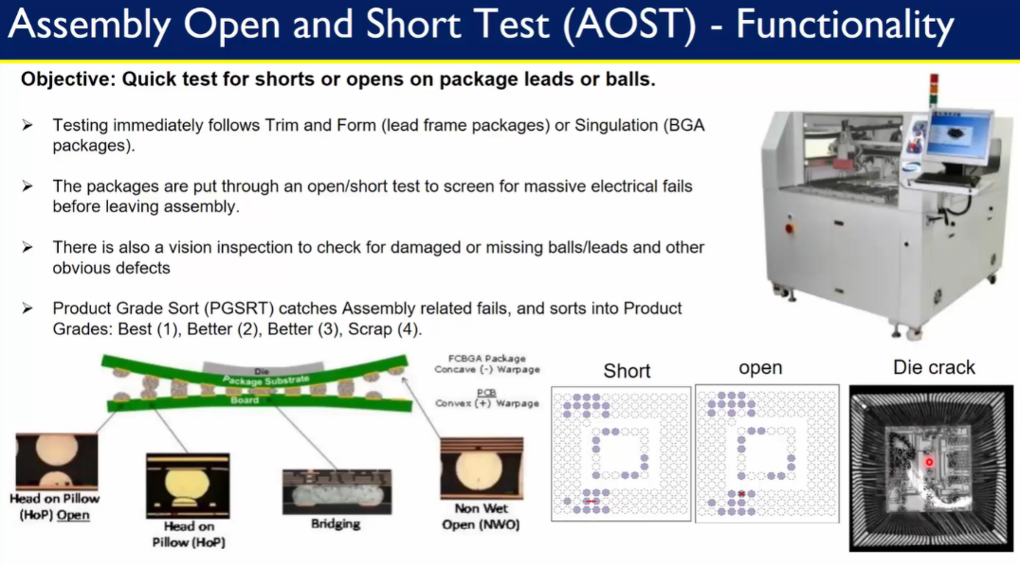

1. Reliability and Performance Testing of Semiconductor Packages

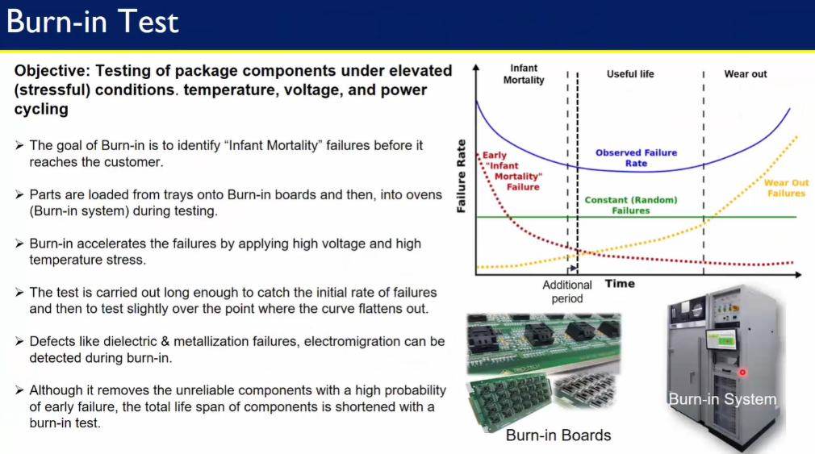

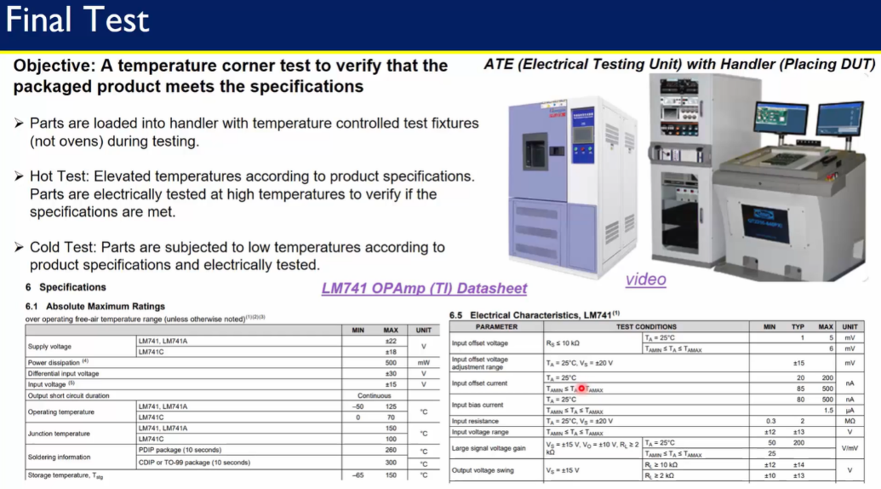

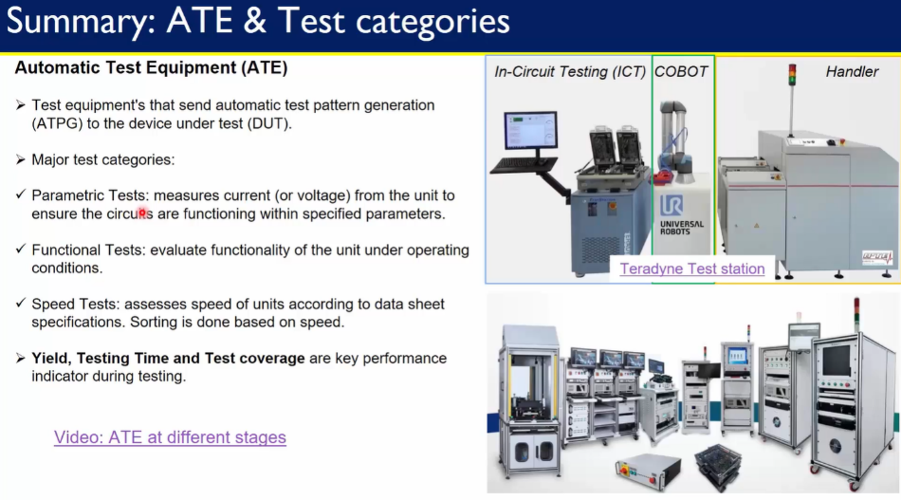

**MODULE 5**

**Package Design and Modeling: Building a Semiconductor Package from Scratch**

Hands on lab to design wire bond package from scratch.

Designing die, substrate, underfill, die attach, wire bonds, mold with appropriate materials, dimensions which include co-ordinates, thickness of material.

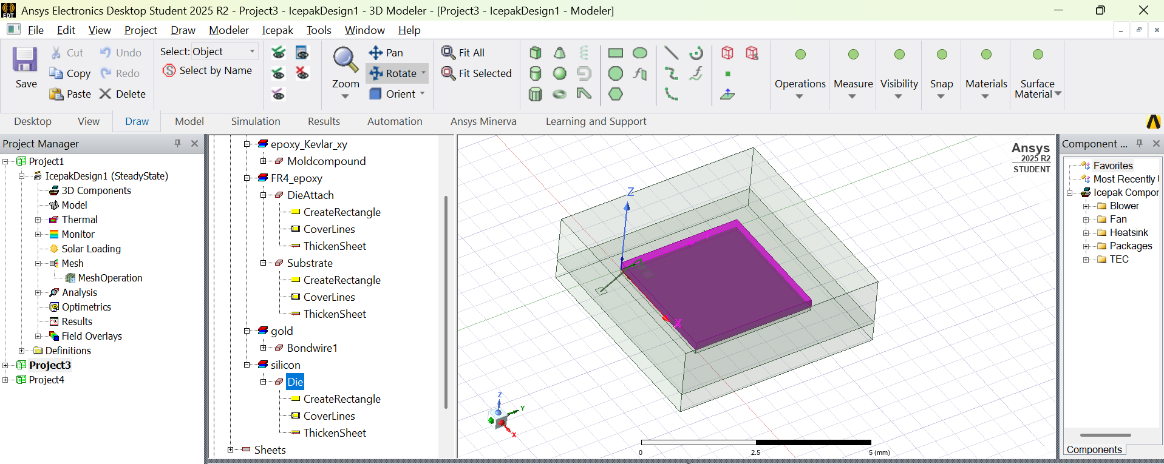

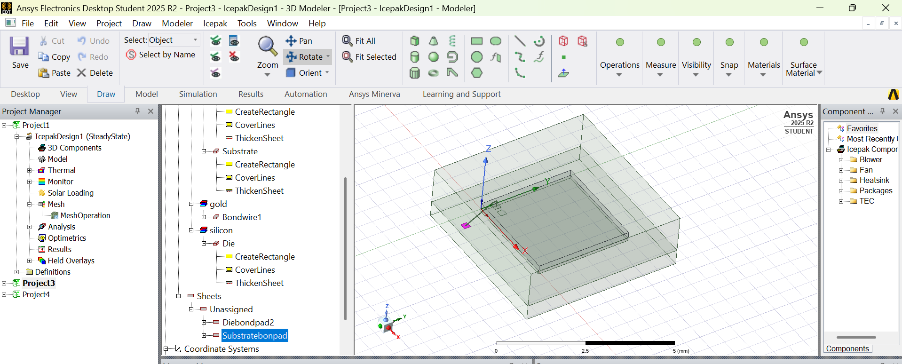

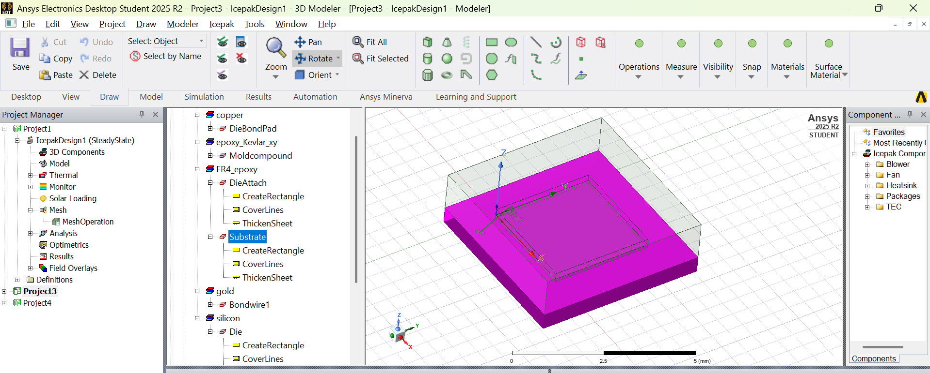

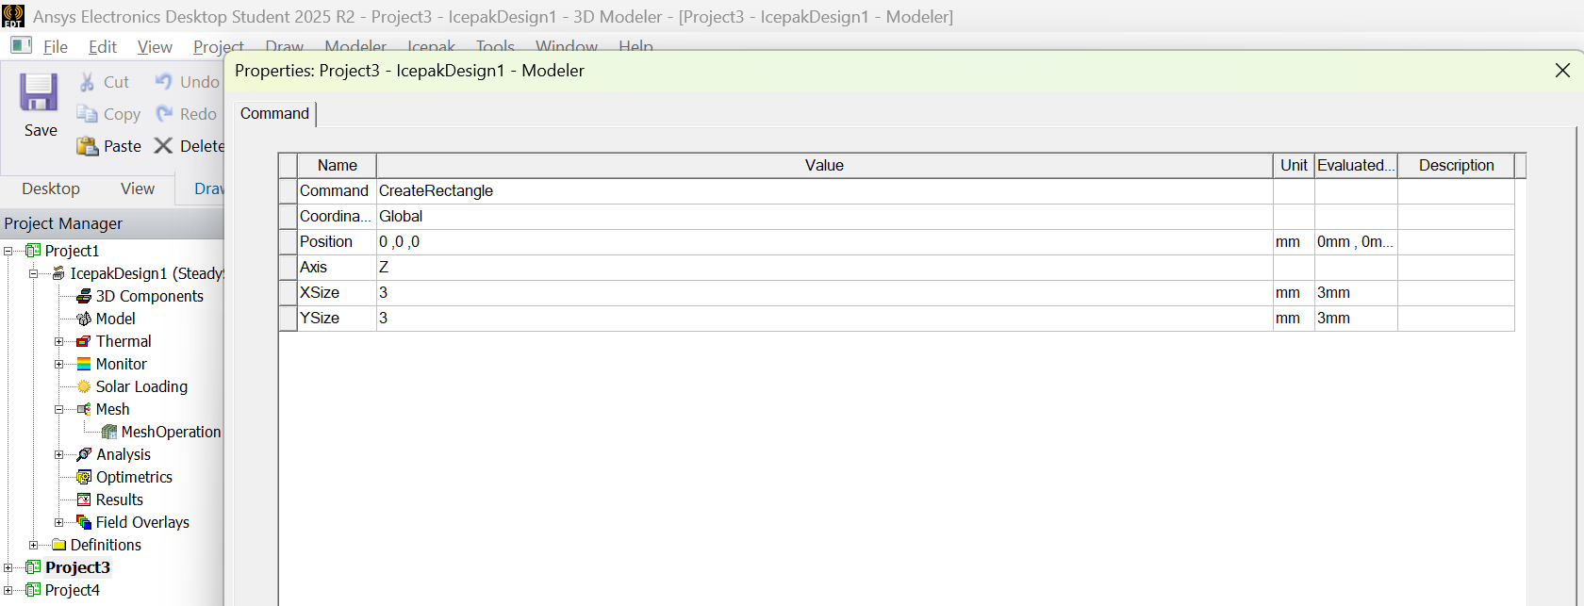

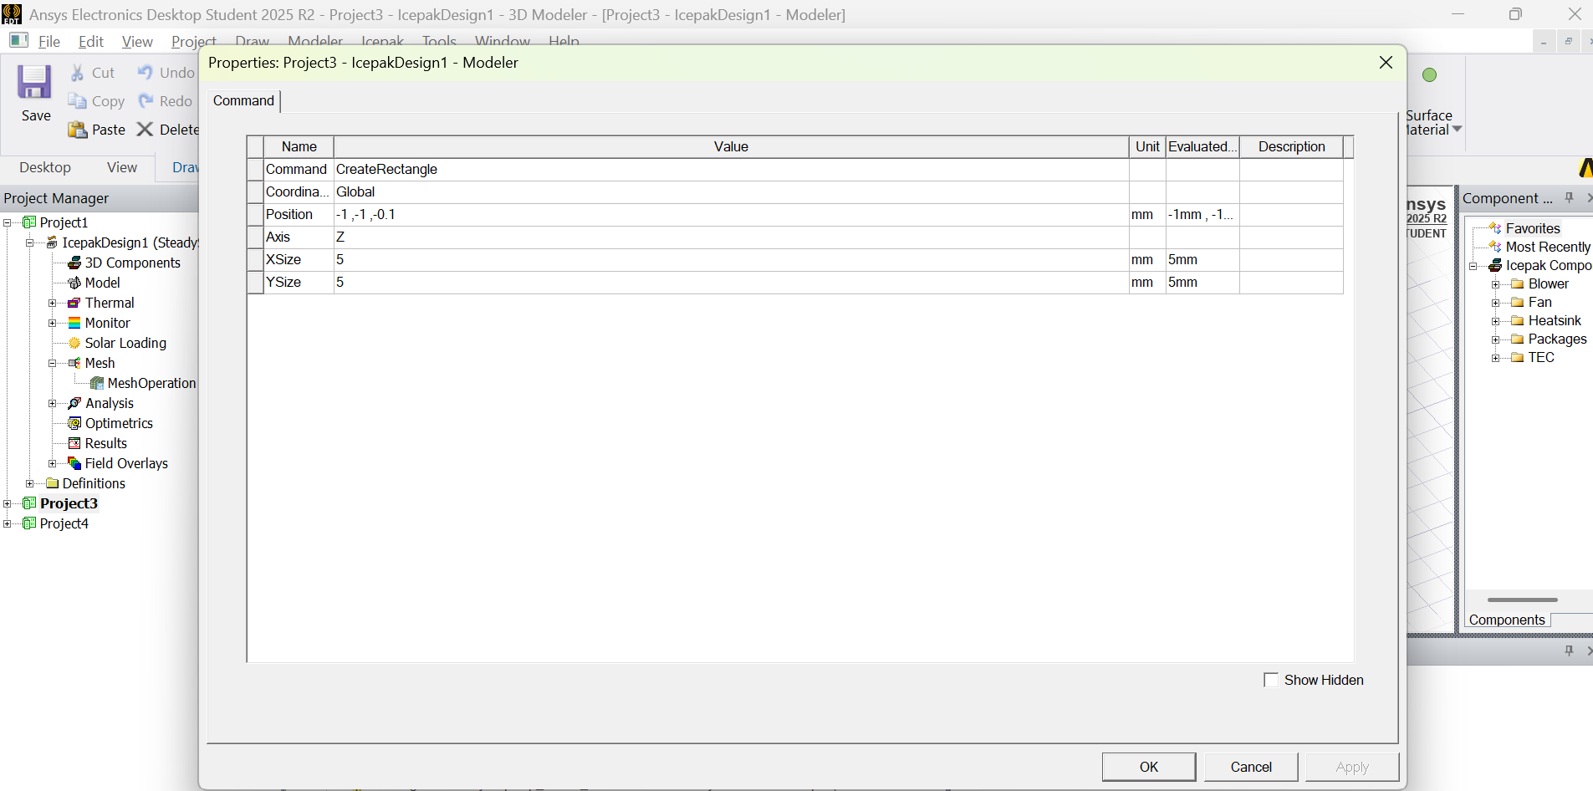

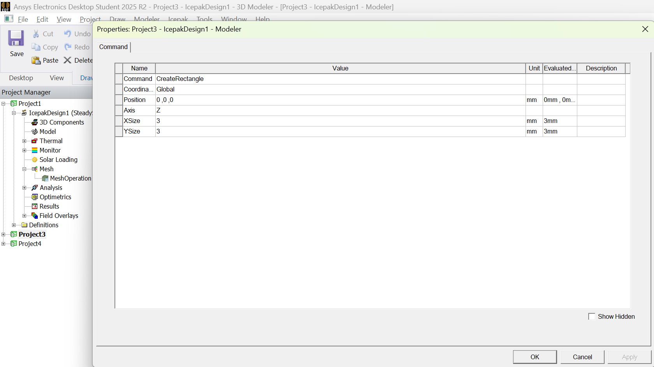

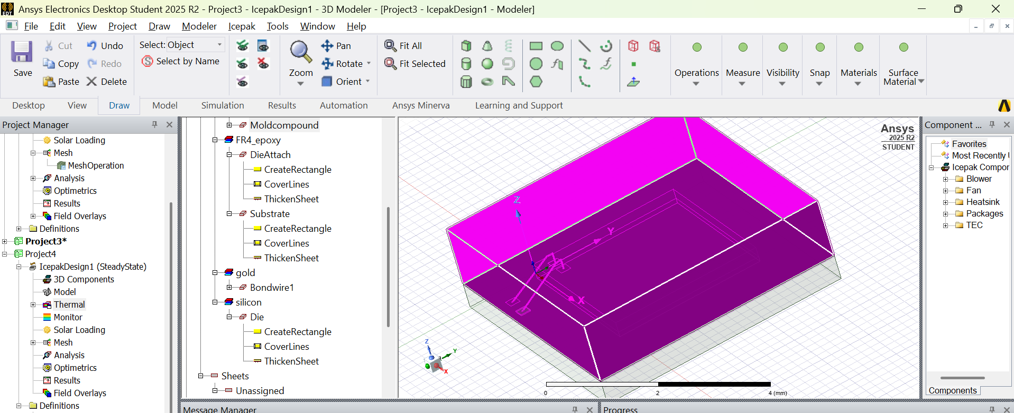

Choosing dimensions for wire bond according to JPEC standards

